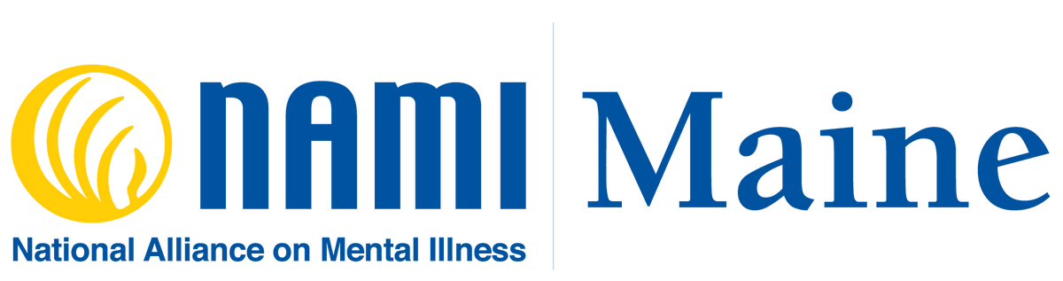
Visit

www.namimaine.org
To Learn More
Follow Us @NAMIMaine
(800) 464.5767. x 2301
(800) 464.5767. x 2301
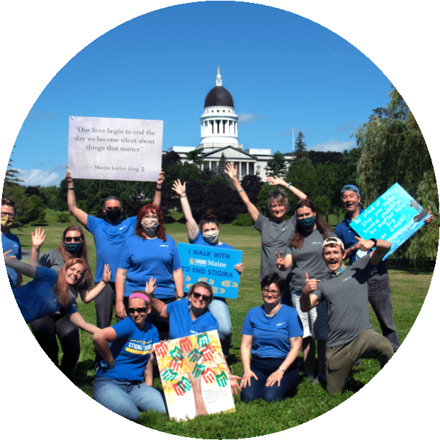
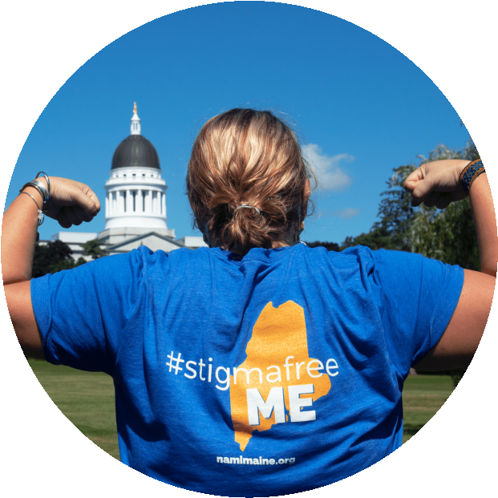
LET'S FUNDRAISE
ALL YEAR
LONG
52
Water St,
Hallowell, ME 04347
Follow Us @NAMIMaine
Follow Us @NAMIMaine
For inquiries contact our Development Team
events@namimaine.org - (800) 464.5767. x 2303

FUN, CREATIVE, AND LIFESAVING FUNDRAISER IDEAS

- Donation-Based Yoga Class: Keep it small or plan a big event! Yoga is a popular and beneficial mental health tool. Celebrate and raise awareness for NAMI Maine Walk Your Way event by hosting/teaching a yoga class. This can happen anywhere, in-person or virtually.
- How: Invite your friends (in-person of via Zoom) to join you in a relaxing and rewarding yoga flow! Encourage others to either pay to participate, join your walk team, or donate to your cause.
- Donate Your Birthday: Do you have a birthday coming up? Have your social media community help you raise funds for mental health to celebrate your special day!
- How: Email NAMI Maine (contacts below) to receive a video tutorial!
- Challenges: Looking for a way to fundraise and stay active? The NAMI Maine Walk Your Way is the perfect occasion. Combining a personal goal/activity while raising awareness is a win all around! Challenges can include a 5K, jump rope, step challenge, the sky’s the limit.
- How: Simple! Think of a challenge that not only works for you, but motivates you. Encourage others to donate in support of your challenge/cause, or invite them to join you.
- Donation Drive: Looking for a way to get your customers involved? How about staff? A donation drive is a simple and effective tool to share NAMI Maine’s mission, and raise funds.
- How: Set up a station to collect and advertise your fundraising goal. Watch the donations come in and share the reason why you walk for mental health along the way.
- Steps on Steps: 2000? 3000? Goals can motivate you no matter how big or small.
- How: Have your team pledge to walk in honor of NAMI Maine and raise awareness for #mentalhealthforall!
- Live Stream Event: Host a livestream event on your social media! Your event can feature trivia, guest speakers, even performers. Make it your own!
- How: Host a Live Stream Event on Facebook or Instagram (or both)! For organization purposes, create an agenda of what you’d like to include during the live. Linking your giving pages in the comments is a good place to start!
- Golf Tournament: A golf tournament is a great way to raise awareness, watch funds grow, and get people outside! Gather your supporters and golf fanatics to put on a fun event in honor of NAMI Maine.
- How: Reach out to a local golf course as a venue option. Invite your friends, family, and community to a golf tournament. Players can pay to play, or donate towards your fundraising goal.
- Ping Pong Tournament: A little competition never hurt nobody! Gather your supporters to compete in a fun pin pong match. This tournament can raise both awareness and donations in support of NAMI Maine.
- How: Find a ping-pong table, and invite your friends over for some matches. Encourage others to play, support, and donate towards your fundraising goal.
- Bowl-A-Thon: A classic! Check in with your local bowling alleys and see if they would like to join in the fun and donate free games to charity. Participants can pay to play or donate!
- How: Select your bowling destination and invite your community to join you. Players can pay to play in support of your fundraising goal.
- Karaoke: An event filled with classic hits, entry fees, and awareness!
- How: Zoom or in-person! Download a free Karaoke app on your phone and turn up the jams OR reach out to your local hangout for a chance to use their venue.
- Email Giving Campaign: Create a series of emails (4,5,6, etc.) that shares personal testimonies with links to NAMI Maine giving pages/walk team registration!
- How: NAMI Maine has finished step 1 for you! For customizable template email (contacts below) us today to get started.
- Company Matching: Is your company looking to donate? Support them with a company match!
- How: Reach out to your employer and see if they are interested in donating through a “matching” campaign.
- Chain Restaurant Give-Back Nights: Many large chain restaurants will partner with local communities and charities to donate a percentage of sales to the cause. Families can enjoy a night out, a delicious meal, and give back to charity all at the same time!
- How: Several chain restaurants offer “give-back” nights. The first step is to reach out, and watch the conversation grow.
- Scavenger Hunt: Create a fun scavenger hunt around the office, or community! Use this event to reward committed supporters, raise awareness, and raise donations.
- How: Gather some prizes (of your choosing) and encourage your party to go on a “hunt.” To make this event even more successful, motivate participants to pay to play.
- Change (Penny) Drive: Put coin collection jars around the community to raise money and put that loose change to use!
- How: Keep, collect, and DONATE that change! “Every penny counts,” start putting them towards your fundraising goal today.
- Social Media “Take Overs:” Ask a community sponsor, educator, etc. if they would donate their social media page to you (or vice versa) to reach a larger audience! Use this opportunity to learn, share resources, and provide links to giving pages/walk team registration.
- How: Reach out to an account you love, and see if they’d like to take over your socials for the day. Lay some ground rules, and encourage positive/informative conversations on your social media.
- “Yard Sale:” Host a “yard” sale to raise support for NAMI Maine! This sale can take place anywhere and can feature donated/passed down items. Encourage the community to shop and give back to their community.
- How: This yard sale can take place in your own yard, a unique location, or even on FB Marketplace. Sell your old treasure and donate the profits to support your fundraising goal.
- Board Game Tournament: Create a fun board game tournament to raise money and awareness.
- How: Gather your board games, or see if your community is willing to donate some. Next, decide on a place and time, then start playing!
- Book Swap #MentalHealthEdition: Calling all readers! Plan a book swap with stories that help break down mental health stigma. Participants will swap the stories they are willing to part with and receive a new read in exchange.
- How: Gather your favorite books (could possibly be linked to messages of mental health) and encourage your friends, family, and community to a book swap! Spread awareness and challenge the mind with some new stories. Don’t forget to tag us @NAMIMaine.
- Silent Auction: Gather your community together to place their bids on donated prizes. An exciting event where guests have a chance to win and share their support for the organization.
- How: We encourage you to gather donated prizes for this event to eliminate any extra costs. The event can take place in-person or via a social media platform of your choice. Have participants place their “bids” on items in support of your fundraising goal.
- CLYNK Fundraiser: CLYNK is a great platform to recycle while collecting your deposits in one place! Put some or all of the money towards your fundraising goal.
- How: Put your returnable deposits towards the walk and invite others to do the same
- Offer A Cooking or Baking Class: This can take place in person or virtually! Share your favorite recipe with some friends in support of NAMI Maine.
- How: Encourage viewers/attendees to make a donation (suggest a $ amount) to support your efforts to raise funds for mental health.
Email Template
(Insert Greetings),
As you know, my family like many others have been touched by mental illness. (Describe your personal connection to NAMI Maine here). NAMI Maine is a source of support, education, and hope for Mainers' who are impacted by mental health struggles.
In support of this cause, I will be hosting a (insert peer-to-peer event name) fundraiser. You can support this event with your participation, sharing on social media, or simply making a donation.
If you have any questions, please contact me at (insert contact information) I hope to see you there!
(Insert Salutation)
Post Template – FB/Instagram
- You're Invited! Join us on (insert date) for a (insert event name) fundraiser event! Help support our fundraising goal for NAMI Maine. An organization that is devoted to supporting the well-being, education, and hope of Maine families impacted by mental health.
- Are you a mental health supporter? So are we! Join us on (insert date) for a fun and supportive (insert event name), fundraiser event. Donations will go to supporting NAMI Maine. An organization that provides unwavering support, education, and hope to Maine families impacted by mental health.
YOU ARE NOT ALONE
We are here for you for every step of the way and your mental health journey. If you need support, please contact us!
Fundraiser, Sponsorship & Event Logistics:
Elliott Sharples
Manager of Marketing and Development
events@namimaine.org
(800) 464-5767, ext. 2303
NAMI Maine Helpline
The NAMI Maine Helpline is a mental health resource and referral line for peers, family members, friends, and professionals.
helpline@namimaine.org
(800) 464 - 5767, press 1

